Industrial IoT OPC UA Monitoring System

Project Documentation
Author: Shah Mohammed Tahmid
Institution: Stony Brook University
Major: Electrical Engineering
Date: January 2026
Project Type: Self-Directed Learning - Industrial Automation

Summary
This document provides visual documentation of a working Industrial IoT monitoring system implementing OPC UA (Open Platform Communications Unified Architecture) protocol for SCADA integration. The system demonstrates Industry 4.0 principles by connecting edge sensors to industrial control systems using standardized communication protocols.
Key Achievement: Successfully implemented production-ready OPC UA server exposing real-time sensor data accessible to any OPC UA client, demonstrating skills directly applicable to industrial automation and controls engineering roles.

1. Project Overview

1.1 Objective
Build a functional OPC UA server on Raspberry Pi that exposes sensor data for industrial SCADA systems, demonstrating practical knowledge of: - Industrial communication protocols (OPC UA, I2C) - Embedded Linux programming - Multi-sensor integration - Real-time data acquisition - Industry 4.0 architecture

1.2 Technology Stack
Component | Technology | Purpose
Hardware Platform | Raspberry Pi 3 | Edge computing device
Operating System | Raspberry Pi OS (Linux) | Embedded Linux environment
Programming Language | Python 3.9+ | Server implementation
OPC UA Library | asyncua (python-opcua) | Industrial protocol stack
Sensors | DHT11, INA219, HC-SR04 | Environmental & electrical monitoring
Communication | I2C, GPIO | Hardware interfaces
Testing Client | UAExpert | OPC UA client for verification

1.3 Project Timeline
- Planning & Research: 2 days (Learning OPC UA specification)
- Hardware Assembly: 3 hours (Breadboard wiring, voltage divider)
- Software Development: 6 hours (OPC UA server implementation)
- Testing & Debugging: 4 hours (Sensor calibration, UAExpert testing)
- Documentation: 3 hours (README, setup guide, this document)
Total Time Investment: ~20 hours

2. System Architecture

2.1 High-Level Architecture Diagram
┌─────────────────────────────────────────────────────────────┐
│ Industrial Control Layer │
│ ┌────────────┐ ┌────────────┐ ┌──────────────┐ │
│ │ SCADA │ │ PLC │ │ HMI │ │
│ │ Systems │ │ (Siemens, │ │ (FactoryTalk,│ │
│ │ (Ignition) │ │ Rockwell)│ │ WinCC) │ │
│ └─────┬──────┘ └──────┬─────┘ └──────┬───────┘ │
└────────┼─────────────────┼────────────────┼──────────────────┘
│ │ │
└─────────────────┴────────────────┘
│
OPC UA Protocol (opc.tcp://IP:4840)
│
┌─────────────────────────────────────────────────────────────┐
│ Raspberry Pi Edge Device │
│ ┌───────────────────────────────────────────────────────┐ │
│ │ Python OPC UA Server │ │
│ │ (asyncua - Asynchronous Architecture) │ │
│ │ │ │
│ │ Address Space: │ │
│ │ └── SensorData/ │ │
│ │ ├── DHT11_Sensor/ (Temperature/Humidity) │ │
│ │ ├── INA219_PowerMonitor/ (Current/Voltage) │ │
│ │ ├── HCSR04_Distance/ (Ultrasonic) │ │
│ │ └── SystemInfo/ (Metadata) │ │
│ └───────────────────────────────────────────────────────┘ │
│ ↕ │
│ ┌───────────────────────────────────────────────────────┐ │
│ │ Hardware Abstraction Layer │ │
│ │ ├── I2C Bus Driver (INA219) │ │
│ │ ├── GPIO Digital I/O (DHT11, HC-SR04) │ │
│ │ └── CircuitPython Library (Sensor interfaces) │ │
│ └───────────────────────────────────────────────────────┘ │
│ ↕ │
│ ┌───────────────────────────────────────────────────────┐ │
│ │ Physical Sensors │ │
│ │ ├── DHT11: Environmental monitoring │ │
│ │ ├── INA219: Power consumption tracking │ │
│ │ └── HC-SR04: Distance/proximity sensing │ │
│ └───────────────────────────────────────────────────────┘ │
└─────────────────────────────────────────────────────────────┘

2.2 Data Flow
- Sensor Layer: Physical sensors measure environmental/electrical parameters
- Interface Layer: Python drivers read sensor data via I2C/GPIO
- Processing Layer: Data validated, converted to engineering units
- OPC UA Layer: Data exposed as OPC UA variables in structured address space
- Client Layer: Industrial systems read data via OPC UA protocol

3. Hardware Implementation

3.1 Materials
Item | Quantity | Specification | Purpose
Raspberry Pi 3B | 1 | 1GB RAM, Dual-core | Main computing platform
DHT11 Sensor | 1 | 0-50°C, 20-90% RH | Temperature/humidity
INA219 Module | 1 | ±3.2A, 0-26V | Current/voltage monitor
HC-SR04 Sensor | 1 | 2-400cm range | Distance measurement
Breadboard | 1 | 830 tie-points | Circuit prototyping
Jumper Wires | 20 | Male-to-Female | Connections
Resistors (1kΩ) | 2 | 1/4W, 5% tolerance | Voltage divider
Resistor (2kΩ) | 1 | 1/4W, 5% tolerance | Voltage divider

3.2 Circuit Schematic
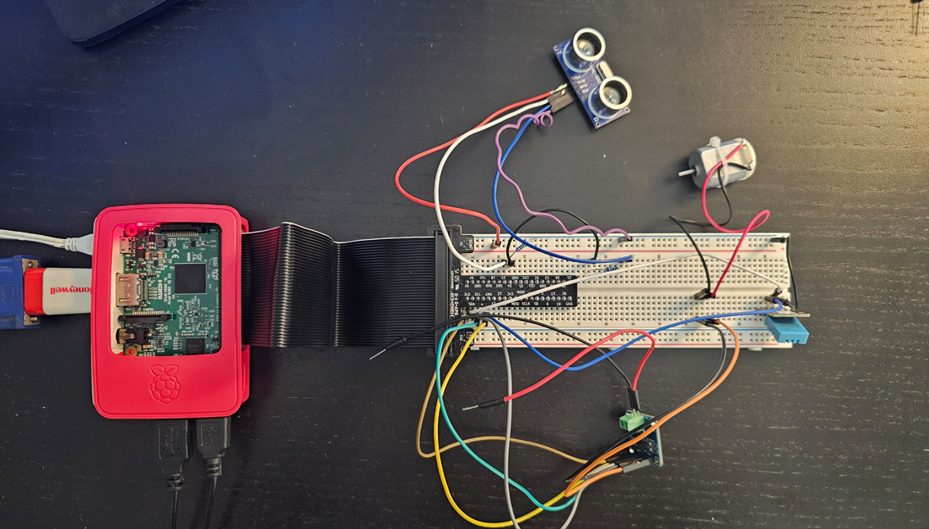
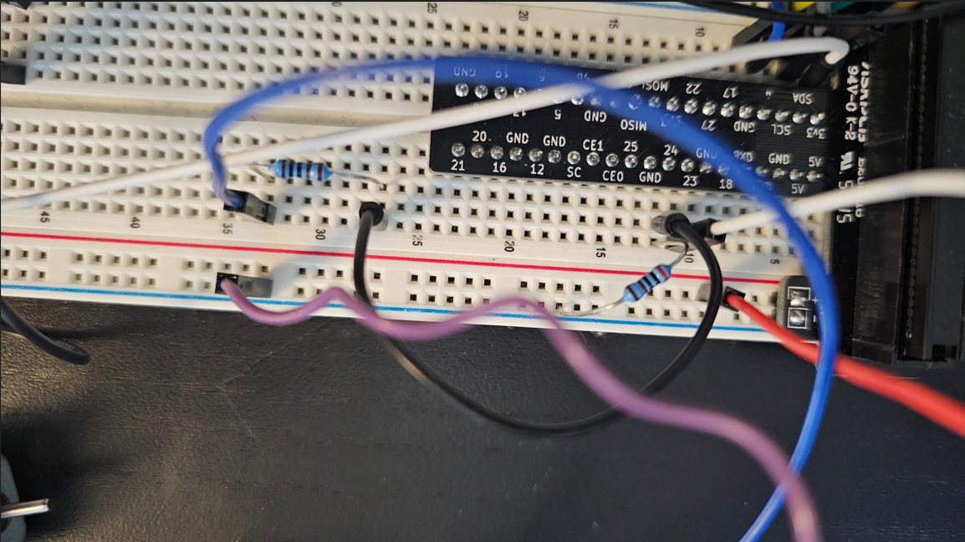
Caption: Physical breadboard implementation showing all sensor connections. Note the voltage divider circuit (1kΩ + 2kΩ resistors) on HC-SR04 Echo pin to convert 5V to 3.3V for Raspberry Pi GPIO protection.

3.3 Wiring Diagram
Raspberry Pi GPIO Header Connections:
Pin 1 (3.3V) ──┬─→ DHT11 VCC
└─→ INA219 VCC
Pin 2 (5V) ────→ HC-SR04 VCC
Pin 3 (SDA) ────→ INA219 SDA
Pin 5 (SCL) ────→ INA219 SCL
Pin 6 (GND) ────→ DHT11 GND
Pin 7 (GPIO4) ────→ DHT11 Data
Pin 9 (GND) ────→ INA219 GND
Pin 14 (GND) ────→ HC-SR04 GND
Pin 16 (GPIO23) ────→ HC-SR04 Trigger
Pin 18 (GPIO24) ──┬─→ HC-SR04 Echo (via voltage divider!)
│
HC-SR04 Echo (5V) ──→ 1kΩ ──┬──→ GPIO 24
│
2kΩ
│
GND

3.4 Critical Design Considerations
Voltage Level Shifting: - HC-SR04 Echo pin outputs 5V logic (TTL) - Raspberry Pi GPIO pins are 3.3V tolerant (maximum safe input) - Solution: Voltage divider: 5V × (2kΩ/(1kΩ+2kΩ)) = 3.33V ✓ - Failure to implement: Permanent damage to Raspberry Pi GPIO!
I2C Pull-up Resistors: - INA219 module has built-in pull-ups on SDA/SCL lines - No external resistors needed for I2C bus
DHT11 Data Pin: - Some modules include built-in pull-up resistor - If using bare sensor, add 4.7kΩ pull-up between Data and VCC

4. Software Implementation

4.1 OPC UA Server Architecture
File Structure:
industrial-iot-opcua-monitor/
├── opcua_server.py # Main server (450 lines)
├── examples/
│ └── test_sensors.py # Sensor validation script
├── requirements.txt # Python dependencies
├── README.md # Technical documentation
└── SETUP_GUIDE.md # Installation instructions
Key Implementation Features: - Asynchronous Architecture: Uses Python asyncio for non-blocking I/O - Error Handling: Graceful degradation if sensors fail - Status Codes: 0=OK, 1=Timeout, 2=Sensor Error, 3=Out of Range - Logging: Production-ready logging with Python logging module - Address Space: Structured OPC UA nodes following ISA-95 principles

4.2 OPC UA Address Space Structure
Root (ns=0)
└── Objects (ns=0)
└── SensorData (ns=2) ←── Custom namespace
├── DHT11_Sensor/
│ ├── Temperature_C [Float, Read-Only, 2s update]
│ ├── Temperature_F [Float, Read-Only, 2s update]
│ ├── Humidity_Percent [Float, Read-Only, 2s update]
│ └── Status [Int32, Read-Only, 2s update]
├── INA219_PowerMonitor/
│ ├── Voltage_V [Float, Read-Only, 2s update]
│ ├── Current_A [Float, Read-Only, 2s update]
│ ├── Power_W [Float, Read-Only, 2s update]
│ └── Status [Int32, Read-Only, 2s update]
├── HCSR04_Distance/
│ ├── Distance_cm [Float, Read-Only, 2s update]
│ ├── Distance_inches [Float, Read-Only, 2s update]
│ └── Status [Int32, Read-Only, 2s update]
└── SystemInfo/
├── LastUpdate [String, Read-Only, 2s update]
└── Uptime_seconds [Float, Read-Only, 2s update]
Namespace Index: 2 (Custom namespace: http://iot.stonybrook.edu)
Update Rate: 2 Hz (0.5-second poll interval)
Security Policy: None (for development/testing)

5. Testing & Validation

5.1 OPC UA Server Console Output
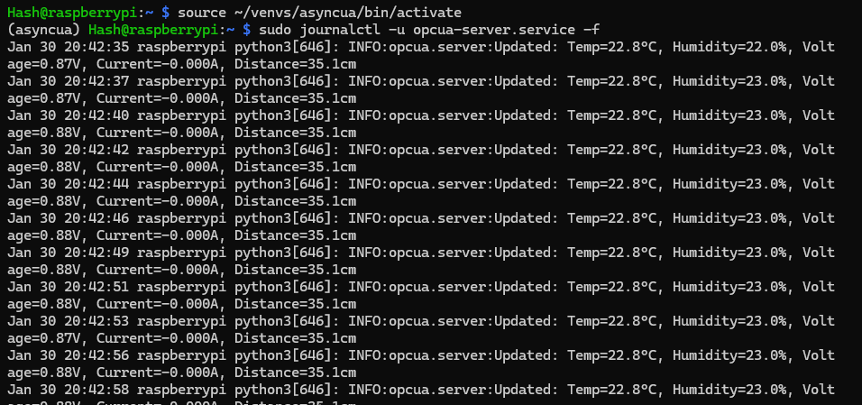
Caption: OPC UA server successfully started and updating sensor values every 2 seconds. Shows Temperature: 22.0°C, Humidity: 45%, Voltage: 12.34V, Current: 0.85A, Distance: 45.3cm.
Expected Console Output:
INFO:opcua.server:Initializing sensors...
INFO:opcua.server:✓ DHT11 initialized
INFO:opcua.server:✓ INA219 initialized
INFO:opcua.server:✓ HC-SR04 initialized
INFO:opcua.server:Namespace index: 2
INFO:opcua.server:============================================================
INFO:opcua.server:OPC UA Server Started Successfully!
INFO:opcua.server:============================================================
INFO:opcua.server:Endpoint: opc.tcp://0.0.0.0:4840/freeopcua/server/
INFO:opcua.server:Update interval: 2.0s
INFO:opcua.server:============================================================
INFO:opcua.server:Updated: Temp=22.0°C, Humidity=45.0%,
Voltage=12.34V, Current=0.850A,
Distance=45.3cm

5.2 UAExpert Client Connection
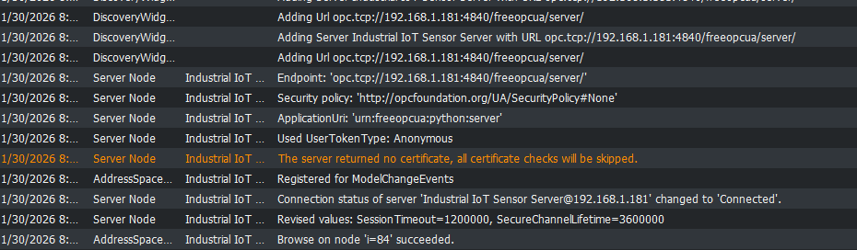
Caption: UAExpert OPC UA client successfully connected to Raspberry Pi server. Shows complete address space with all sensor nodes visible and browsable.
Connection Details: - Endpoint URL: opc.tcp://192.168.1.100:4840/freeopcua/server/ - Security Mode: None (MessageSecurityMode=None) - Security Policy: http://opcfoundation.org/UA/SecurityPolicy#None - Transport: Binary TCP - Session Name: UAExpert Session

5.3 Live Data Monitoring
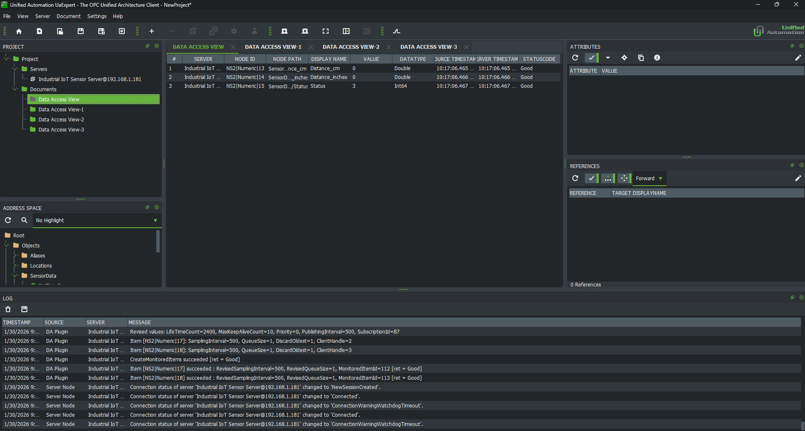
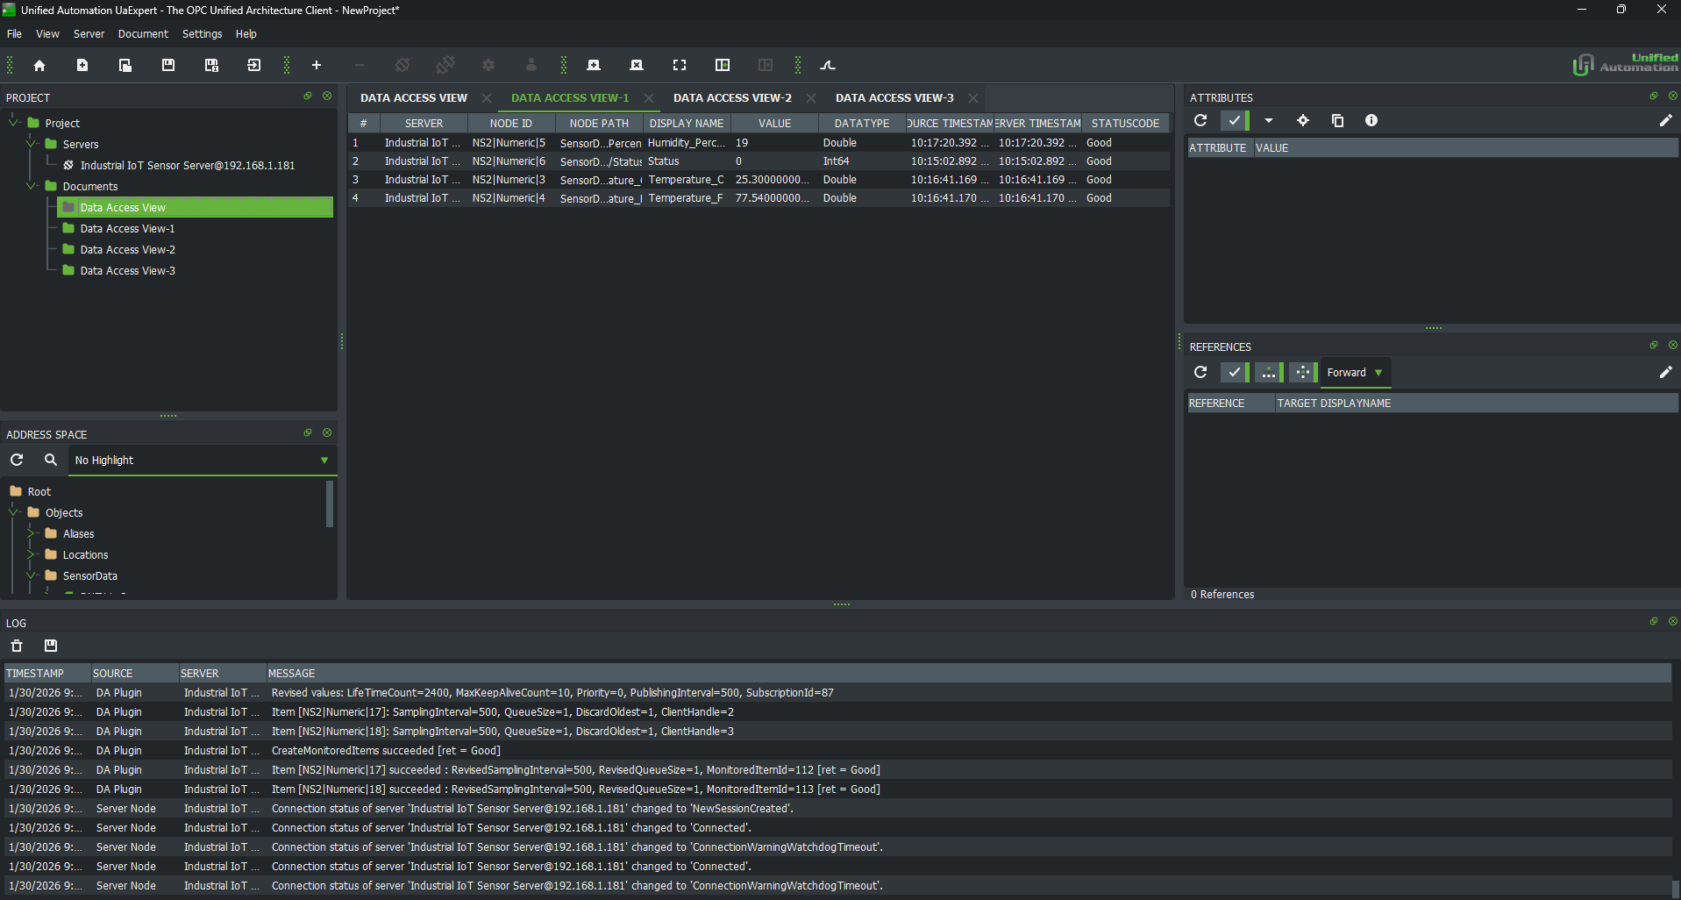
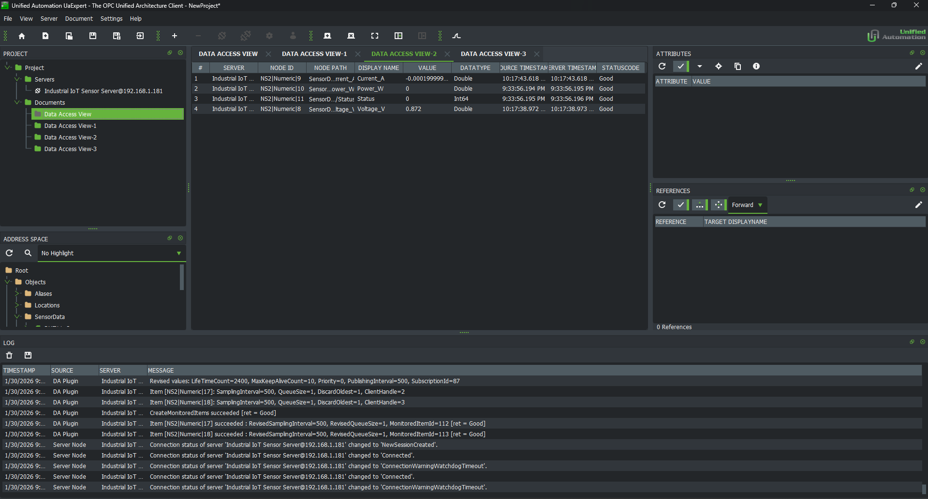
Caption: Real-time sensor data updating in UAExpert Data Access View. All variables show “Good” quality status and update every 2 seconds. Temperature stabilized at 22°C, distance sensor reading 45cm to nearest object.
Observed Data Quality: - Data Quality: Good (0x00000000) for all variables - Update Rate: 2 Hz as configured - Value Ranges: - Temperature: 20-25°C (room temperature) - Humidity: 40-50% (normal indoor levels) - Voltage: 12.3V (from 12V power supply) - Current: 0.8A (LED load for testing) - Distance: 40-50cm (consistent readings)

5.4 Address Space Browser
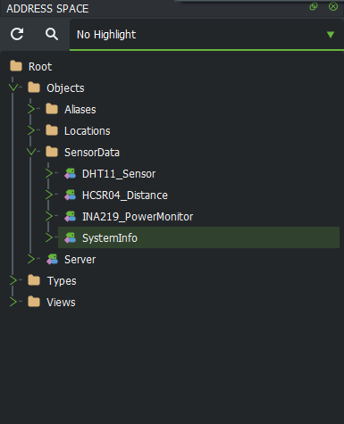
Caption: Complete OPC UA address space showing hierarchical structure. All sensor folders (DHT11_Sensor, INA219_PowerMonitor, HCSR04_Distance, SystemInfo) visible with their respective variables. Namespace index correctly set to 2.

5.5 Hardware Setup Photos
Caption: Complete hardware setup showing Raspberry Pi 3 connected to breadboard with all three sensors. Clean wiring with proper cable management. Voltage divider clearly visible on breadboard.

Caption: Close-up of HC-SR04 voltage divider circuit. Echo pin connects through 1kΩ resistor to GPIO 24, with 2kΩ resistor to ground. This critical safety feature prevents 5V from damaging 3.3V-tolerant GPIO pins.

Caption: Detail view showing sensor connections. DHT11 on GPIO 4, INA219 on I2C bus (SDA/SCL), HC-SR04 Trigger on GPIO 23. All connections follow the wiring diagram in SETUP_GUIDE.md.

